Sacajawea Hotel – The First 100 Years
Celebrating a centennial with a major renovation
By Mona L. Hayden

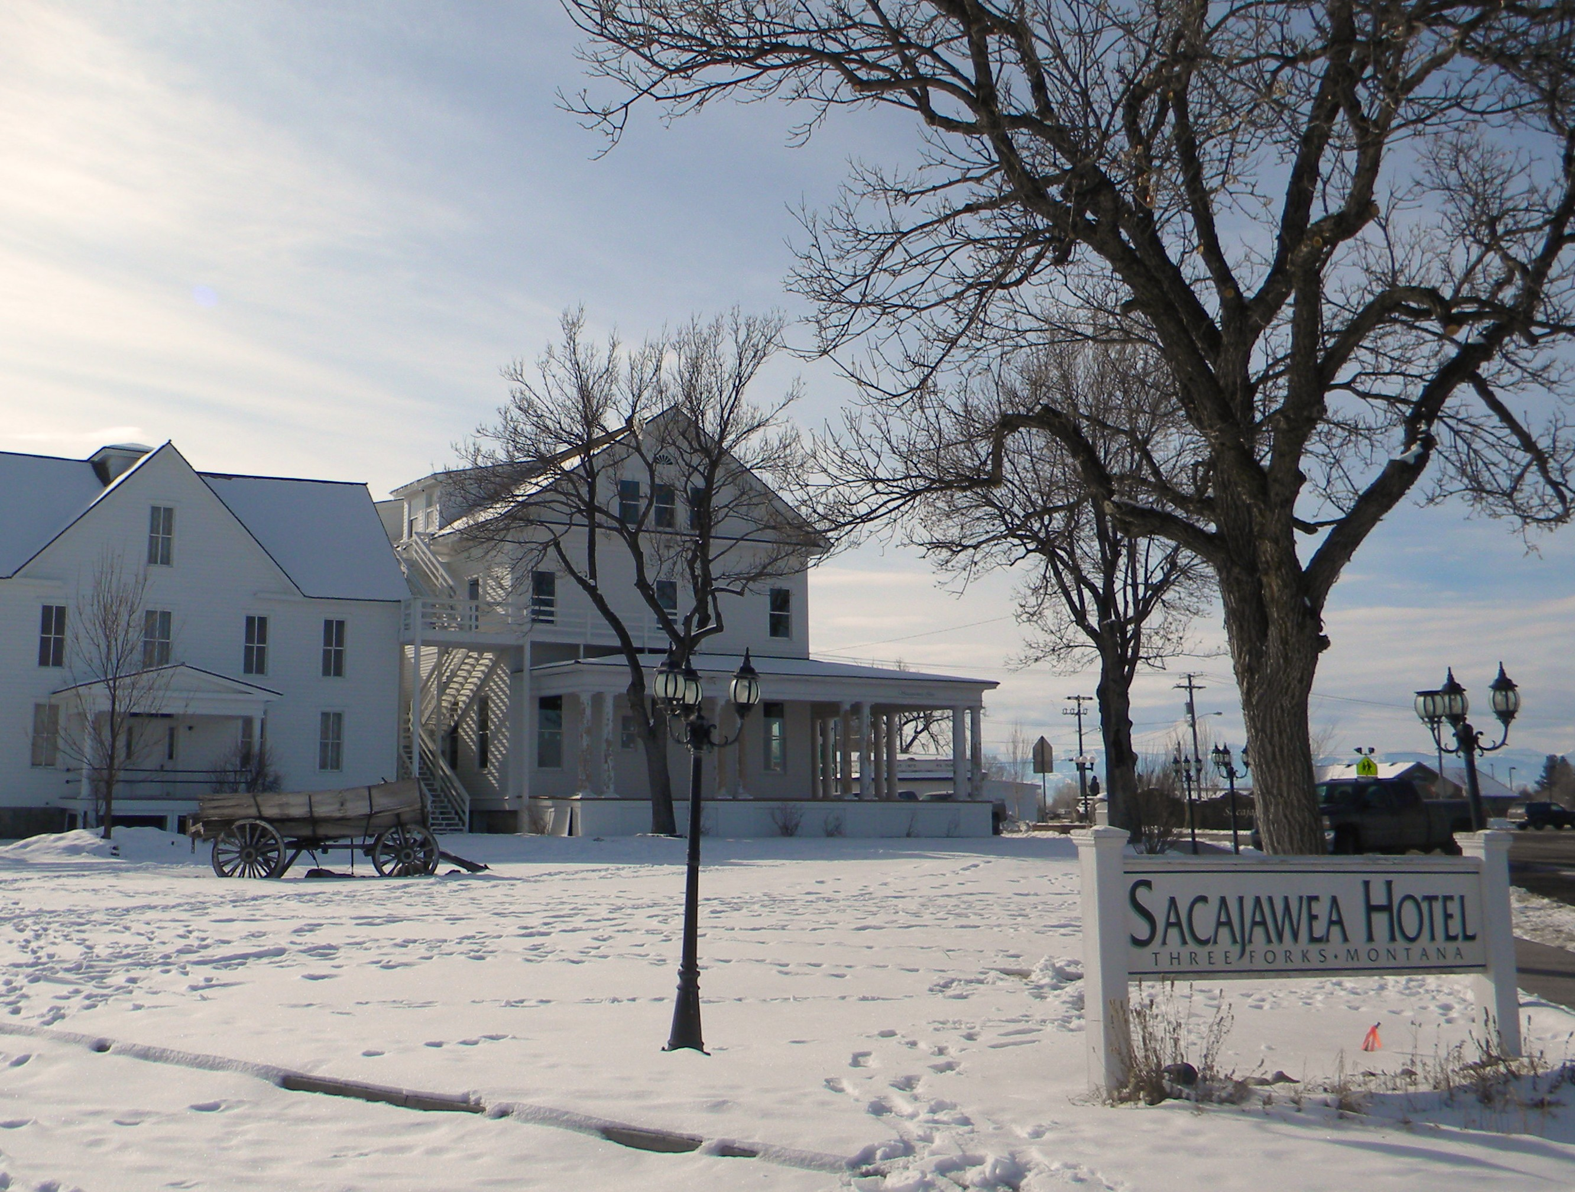Nestled high in the Rockies in the quaint little mountainside town of Three Forks, Montana sits the majestic Sacajawea Hotel, circa 1910. Celebrating 100 years of providing food and shelter to generations, this historic property has recently undergone a complete renovation by the Folkvord family who purchased the property in the Fall of 2009.
From reclaiming its original solid white façade to boasting a reconstructed front porch that wraps the front and east side of the building, this was just the beginning. Saws buzzing and hammers swinging, the Sac now sports an updated grand entrance, a large new deck off the upstairs bar for alfresco dining and entertaining, and efficient windows and doors. Most every board in this 100 year old structure has been restored, refurbished, or refinished. Not to be outdone, the 29 beautifully designed guest rooms and suites have also received a facelift with new flooring, updated bathrooms with subway tiles and handcrafted wood details, modern fixtures, comfy beds with fresh new linens, armoires, and flatscreen televisions. The lobby has also been refinished to perfection while retaining its authentic light fixtures, steam heat registers, and dark spruce beams supporting the 14’ ceiling. The original fir boards were salvaged from the front porch floor and now embrace the walls of the bar as wainscoting.
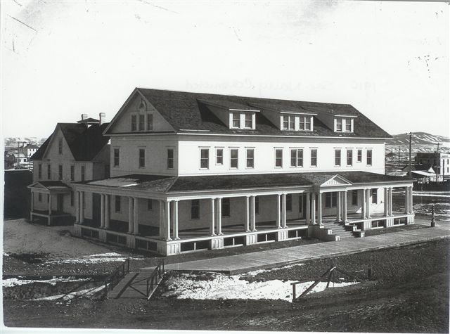Charm and sophistication, coupled with modern convenience and unrivaled hospitality, define the stately hotel’s transformation from a forgotten treasure into a prime destination for visitors and locals alike. The recent renovation hasn’t dismissed the original character or history, a grand story in itself.
Circa 1910
The Sacajawea Hotel was built in 1910 as a stopping point for rail travelers wishing to visit Yellowstone, just a short 100 miles away by horse and buggy. She served them well and continues to provide comfort and pleasure to visitors. The infamous hotel was listed on the National Historic Register in 1982. Located on the corner of Main Street, just minutes from the Headwaters of the Missouri, the Sacajawea is now dressed to the nines, ready to receive a house full of guests in celebration of this milestone. Come stay for a night, a weekend, or as long as you’d like. The hotel is scheduled to reopen in April, 2010.
In typical Montana fashion, the Sacajawea offers room to stretch your legs and breathe in fresh mountain air. You’re invited to relax on the front porch with a cool drink in hand, watching the sunset color the western skies after a full day of fishing, hiking, skiing, or exploring the countless recreational opportunities and wildlife nearby. Or perhaps you’d prefer spending a day golfing or soaking in one of the many hot springs. With three state parks just minutes away, Yellowstone about 100 miles, and Bozeman, Butte, and Helena each within an hour’s drive, you only have yourself to blame if you miss out on the fun!
‘What happens in the Sack, stays in the Sac.’
Dean Folkvord, 2010
After years of neglect, the downstairs Sacajawea bar has regained its original flair with heavy wood, dim lights, and a low slung ceiling. While maintaining the structural integrity of the building, the reclaimed wood in the bar has been refinished and walls repositioned but 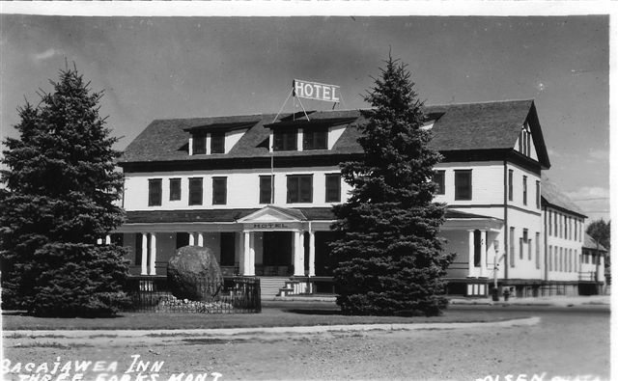the character and history remain strong. Imagine the elbows of time that have rested here and the conversations that ensued. This modern-day saloon is also available for private meetings, parties, or just a casual hideout with friends. The bar opens daily at 11am for lunch and hosts live entertainment on the weekends – a great place to meet the locals.
1930's
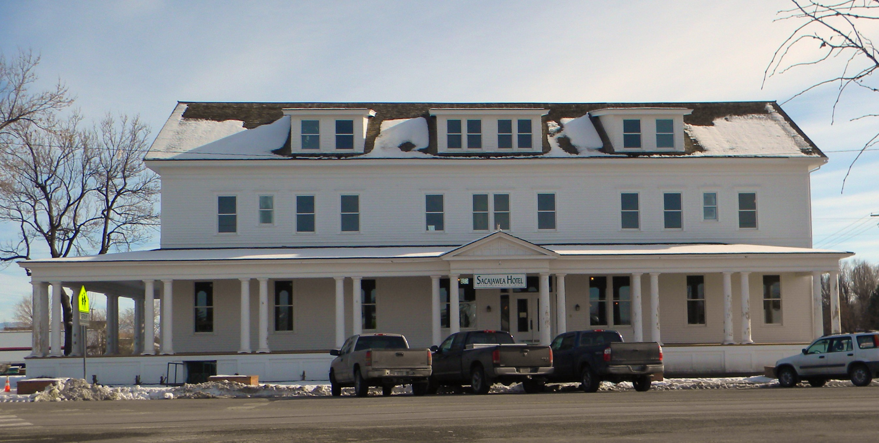Enjoy a pleasant meal upstairs at Pompey’s Grill, aptly named for the son of Sacajawea. After growing up in the western wilderness he spent much of his life abroad, becoming educated. His experience and culture are loosely translated in the menu of his namesake restaurant as Pompey appreciated an array of foods from across the globe. The newly remodeled executive kitchen now boasts a wood fired stove, state-of-the-art appliances, equipment, and Chef Matt Israel. From soups and sandwiches, to steaks and continental cuisine, the semi-casual menu is sure to satisfy most any appetite. The main dining area comfortably accommodates 60 guests with another private room seating an additional 20-24. Lunch is served everyday in the bar and the dining room is open every evening.
2010 Renovation

Sacajawea, the Shoshone who guided Lewis and Clark through the area in 1805, was instrumental in shaping the history of America and her legacy lives on. Today, her memory is honored within the boundaries of the hotel and at the Sacajawea Park, a historical point of interest directly across the street.
You simply won’t find a better place to kick off your boots and make yourself at home than the Sacajawea Hotel in Three Forks, Montana, where comfort and luxury blend beautifully. Accommodations start at $99 per night (one full-size bed). Large parties are welcome.
Call 1-406-285-6515 or 1-888-SACAJAWEA for reservations or visit www.sacajaweahotel.com. They’re open and ready for business.
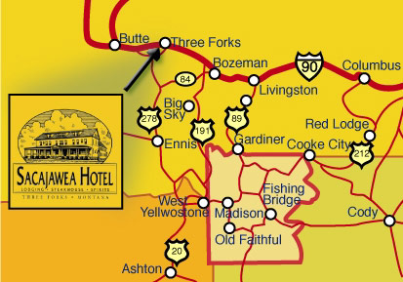 Directions: From I-90, take the Three Fork Exit (#278), turn on the Frontage Road and head south into Three Forks on Main Street. The Sac is one of the first buildings past the Headwaters Golf Course. From US-287, take US-10 east into Three Forks. Continue on US-10 and take a left on Main Street. Proceed North and the Sacajawea Hotel is on the right at the corner of Main and Ash.

Mona L. Hayden is a Louisiana native making her way to Montana, where her heart lies. Soon to be a resident of Three Forks, she can be reached at monalh@bellsouth.net.

